Functions for data preparation and cleaning

[❮ Previous](https://www.w3schools.com/datascience/ds_python_dataframe.asp)[Next ❯](https://www.w3schools.com/datascience/ds_analyze_data.asp)

This chapter shows three commonly used functions when working with Data Science: max(), min(), and mean().

## The Sports Watch Data Set

|  |  |  |  |  |  |
| --- | --- | --- | --- | --- | --- |
| **Duration** | **Average_Pulse** | **Max_Pulse** | **Calorie_Burnage** | **Hours_Work** | **Hours_Sleep** |
| 30 | 80 | 120 | 240 | 10 | 7 |
| 30 | 85 | 120 | 250 | 10 | 7 |
| 45 | 90 | 130 | 260 | 8 | 7 |
| 45 | 95 | 130 | 270 | 8 | 7 |
| 45 | 100 | 140 | 280 | 0 | 7 |
| 60 | 105 | 140 | 290 | 7 | 8 |
| 60 | 110 | 145 | 300 | 7 | 8 |
| 60 | 115 | 145 | 310 | 8 | 8 |
| 75 | 120 | 150 | 320 | 0 | 8 |
| 75 | 125 | 150 | 330 | 8 | 8 |

The data set above consists of 6 variables, each with 10 observations:

* **Duration** - How long lasted the training session in minutes?
* **Average_Pulse** - What was the average pulse of the training session? This is measured by beats per minute
* **Max_Pulse** - What was the max pulse of the training session?
* **Calorie_Burnage** - How much calories were burnt on the training session?
* **Hours_Work** - How many hours did we work at our job before the training session?
* **Hours_Sleep** - How much did we sleep the night before the training session?

We use underscore (_) to separate strings because Python cannot read space as separator.

## The max() function

The Python max() function is used to find the highest value in an array.

### Example

Average_pulse_max = max(80, 85, 90, 95, 100, 105, 110, 115, 120, 125)  
  
print (Average_pulse_max)

## The min() function

The Python min() function is used to find the lowest value in an array.

### Example

Average_pulse_min = min(80, 85, 90, 95, 100, 105, 110, 115, 120, 125)  
  
print (Average_pulse_min)

## The mean() function

The NumPy mean() function is used to find the average value of an array.

### Example

import numpy as np  
  
Calorie_burnage = [240, 250, 260, 270, 280, 290, 300, 310, 320, 330]  
  
Average_calorie_burnage = np.mean(Calorie_burnage)  
  
print(Average_calorie_burnage)

# Data Preparation

## Extract and Read Data With Pandas

Before data can be analyzed, it must be imported/extracted.

In the example below, we show you how to import data using Pandas in Python.

We use the read_csv() function to import a CSV file with the health data:

### Example

import pandas as pd  
  
health_data = pd.read_csv("data.csv", header=0, sep=",")  
  
print(health_data)

### Example Explained

* Import the Pandas library
* Name the data frame as health_data.
* header=0 means that the headers for the variable names are to be found in the first row (note that 0 means the first row in Python)
* sep="," means that "," is used as the separator between the values. This is because we are using the file type .csv (comma separated values)

**Tip:** If you have a large CSV file, you can use the head() function to only show the top 5rows:

### Example

import pandas as pd  
  
health_data = pd.read_csv("data.csv", header=0, sep=",")  
  
print(health_data.head())

## Data Cleaning

Look at the imported data. As you can see, the data are "dirty" with wrongly or unregistered values:

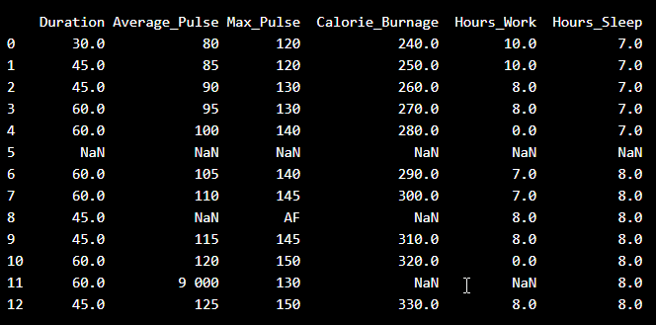

* There are some blank fields
* Average pulse of 9 000 is not possible
* 9 000 will be treated as non-numeric, because of the space separator
* One observation of max pulse is denoted as "AF", which does not make sense

So, we must clean the data in order to perform the analysis.

## Remove Blank Rows

We see that the non-numeric values (9 000 and AF) are in the same rows with missing values.

Solution: We can remove the rows with missing observations to fix this problem.

When we load a data set using Pandas, all blank cells are automatically converted into "NaN" values.

So, removing the NaN cells gives us a clean data set that can be analyzed.

We can use the dropna() function to remove the NaNs. axis=0 means that we want to remove all rows that have a NaN value:

### Example

health_data.dropna(axis=0,inplace=True)  
  
print(health_data)

The result is a data set without NaN rows:

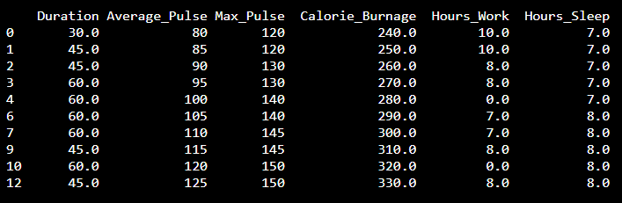

## Data Categories

To analyze data, we also need to know the types of data we are dealing with.

Data can be split into three main categories:

1. **Numerical** - Contains numerical values. Can be divided into two categories:
   * Discrete: Numbers are counted as "whole". Example: You cannot have trained 2.5 sessions, it is either 2 or 3
   * Continuous: Numbers can be of infinite precision. For example, you can sleep for 7 hours, 30 minutes and 20 seconds, or 7.533 hours
2. **Categorical** - Contains values that cannot be measured up against each other. Example: A color or a type of training
3. **Ordinal** - Contains categorical data that can be measured up against each other. Example: School grades where A is better than B and so on

By knowing the type of your data, you will be able to know what technique to use when analyzing them.

## Data Types

We can use the info() function to list the data types within our data set:

### Example

print(health_data.info())

Result:

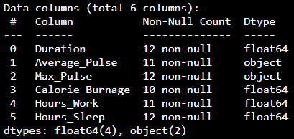

We see that this data set has two different types of data:

* Float64
* Object

We cannot use objects to calculate and perform analysis here. We must convert the type object to float64 (float64 is a number with a decimal in Python).

We can use the astype() function to convert the data into float64.

The following example converts "Average_Pulse" and "Max_Pulse" into data type float64 (the other variables are already of data type float64):

### Example

health_data["Average_Pulse"] = health_data['Average_Pulse'].astype(float)  
health_data["Max_Pulse"] = health_data["Max_Pulse"].astype(float)  
  
print (health_data.info())

Result:

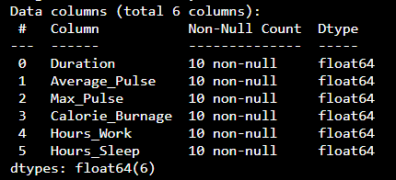

Now, the data set has only float64 data types.

## Analyze the Data

When we have cleaned the data set, we can start analyzing the data.

We can use the describe() function in Python to summarize data:

### Example

print(health_data.describe())

Result:

|  |  |  |  |  |  |  |
| --- | --- | --- | --- | --- | --- | --- |
|  | **Duration** | **Average_Pulse** | **Max_Pulse** | **Calorie_Burnage** | **Hours_Work** | **Hours_Sleep** |
| **Count** | 10.0 | 10.0 | 10.0 | 10.0 | 10.0 | 10.0 |
| **Mean** | 51.0 | 102.5 | 137.0 | 285.0 | 6.6 | 7.5 |
| **Std** | 10.49 | 15.4 | 11.35 | 30.28 | 3.63 | 0.53 |
| **Min** | 30.0 | 80.0 | 120.0 | 240.0 | 0.0 | 7.0 |
| **25%** | 45.0 | 91.25 | 130.0 | 262.5 | 7.0 | 7.0 |
| **50%** | 52.5 | 102.5 | 140.0 | 285.0 | 8.0 | 7.5 |
| **75%** | 60.0 | 113.75 | 145.0 | 307.5 | 8.0 | 8.0 |
| **Max** | 60.0 | 125.0 | 150.0 | 330.0 | 10.0 | 8.0 |

* **Count** - Counts the number of observations
* **Mean** - The average value
* **Std** - Standard deviation (explained in the statistics chapter)
* **Min** - The lowest value
* **25%**, **50%** and **75%** are percentiles (explained in the statistics chapter)
* **Max** - The highest value